First Class Project - tic-tac-toe (איקס עיגול) Game

Instructions:

1. Your mission is to develop and design a tic-tac-toe game.   
   Provide the HTML and CSS for the design of the game. You can use whatever design you like (Including Bootstrap).   
   Make sure your game looks good and understandable to the user.   
     
   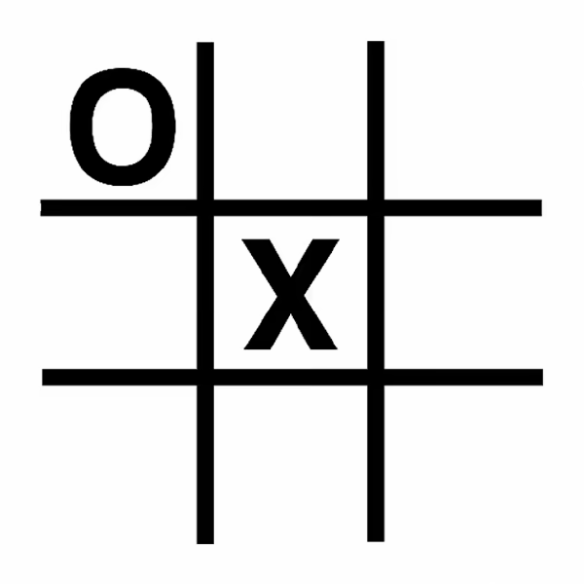

1. Write to logic of the tic-tac-toe game as the following:
   1. In a board game with 9 places each player should put his symbol (X) or (O) in one free place.
   2. If one of the players managed to create an entire row / column or diagonal (אלכסון) with his symbol he wins.   
        
      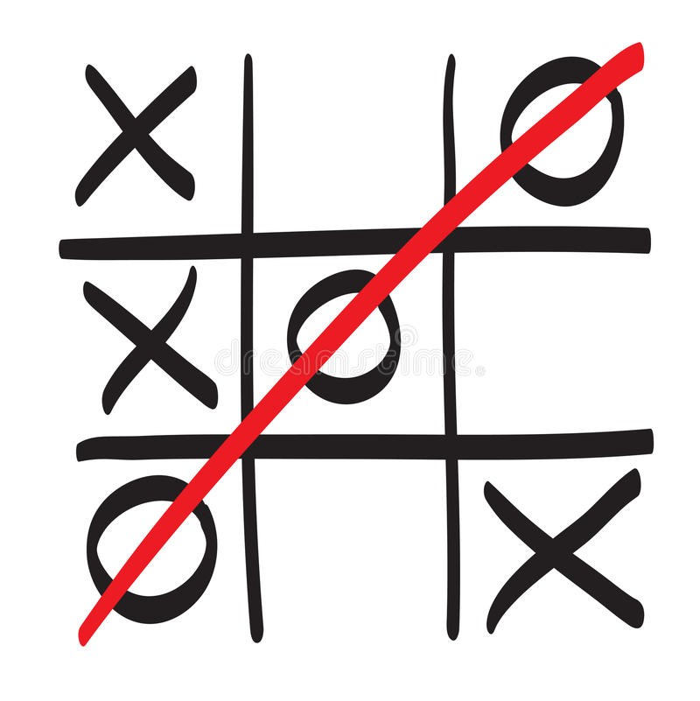
   3. If all the 9 places on the board were filled without anyone who managed to win it's a tie.  
        
        
        
        
        
        
        
        
        
      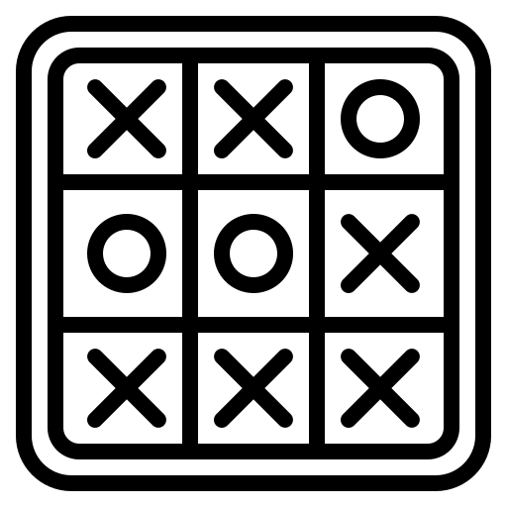
2. Your game should notify the players if someone won or if the game ended with a tie.
3. Your game should allow your users to play again if they want to.
4. Your game should notify a player if he can’t put his symbol in a place for any reason.   
   For example: if a player is trying to put a circle in a place with another symbol, your game should not allow him to do that and notify him about this mistake.
5. Bonos (10 Points):
   1. Provide a way to switch between selecting play against other players and play against the computer.
   2. If the user chose to play against the computer, your code should allow him to do that. (Hint: use random to simulate the computer choises)

